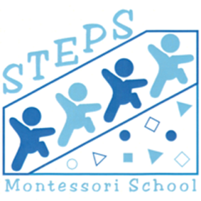
Enrollment Agreement

Date: ___________________________

Child’s Birthdate: ___________________

This agreement is made and entered into between STEPS Montessori of Saginaw, Inc., and

____________________________ (parents’ name). THE SCHOOL hereby accepts

____________________________ (child’s name) for enrollment as a student in the 2026-27 school year.

Students are accepted only for the full academic term without adjustments due to illness, absence or emergency closing of the school. Children must be at least 33 months of age and toilet trained (no pull-ups). Thirty (30) days written notice is required for withdrawal without penalty. The absence of 30 days' notice will hold the parent responsible for one additional tuition payment beyond the withdrawal date.

In our desire to provide a safe and healthy learning environment for the entire classroom, THE SCHOOL reserves ultimate authority in enrollment and dismissal.

A Nonrefundable Placement Fee of $150.00.

Option 1: Nine monthly payments of $835/ $735/$435 due the 1st of the month, September through May.

Option 2: Full Year Tuition paid in full by September 30, 2026, $7,515/$6,615/$3,915.

If you recommend someone and they enroll, we will take $100 off your next month’s tuition.

I understand that it is my obligation to be responsible for all costs associated with the program for which I am enrolled including tuition and any account balances. I also agree to pay all collection costs and attorney fees for the collection of this account if a debt is incurred from any past due balances.

__________________________ __________________________
Parent/Guardian Signature Parent/Guardian Signature

__________________________ __________________________
Parent/Guardian Social Security # Parent/Guardian Social Security #

____________________________________________________________
Address City Zip Code Telephone

May we include photos of your child in promotional materials (Facebook, brochure, website)? Y N Admissions are not limited for reasons of race, color, creed, sex or national origin.
STEPS Montessori updated 7/2020rev.1/26

